Summer Camp Calendar

First Day of Summer Camp Monday July 1st 2019
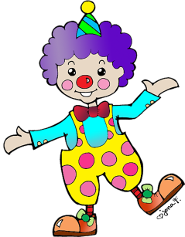
Last Day of Camp Friday August 23rd, 2019
7/1 - 7/3 (Closed the 4th & 5th)
Week 1 Space is the Place

7/8- 7/12
Week 2 Circus Time

7/15 - 7/19
Week 3 Let’s Go Camping

7/22 - 7/26
Week 4 Barnyard Palooza

7/29 - 8/2
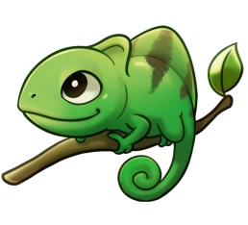
Week 5 Under the Sea
8/5 - 8/9
Week 6 A Reptiles Life

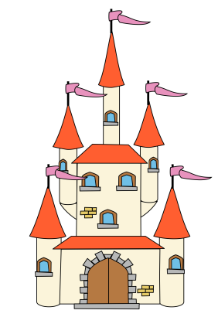
8/12 - 8/16
Week 7 Dinosaur Dig
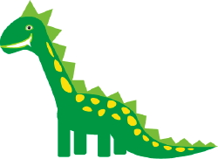
8/19 - 8/23
Week 8 Enchanted Kingdom

Flexible Schedules available at Enrollment
Choose your weeks, choose your Days

